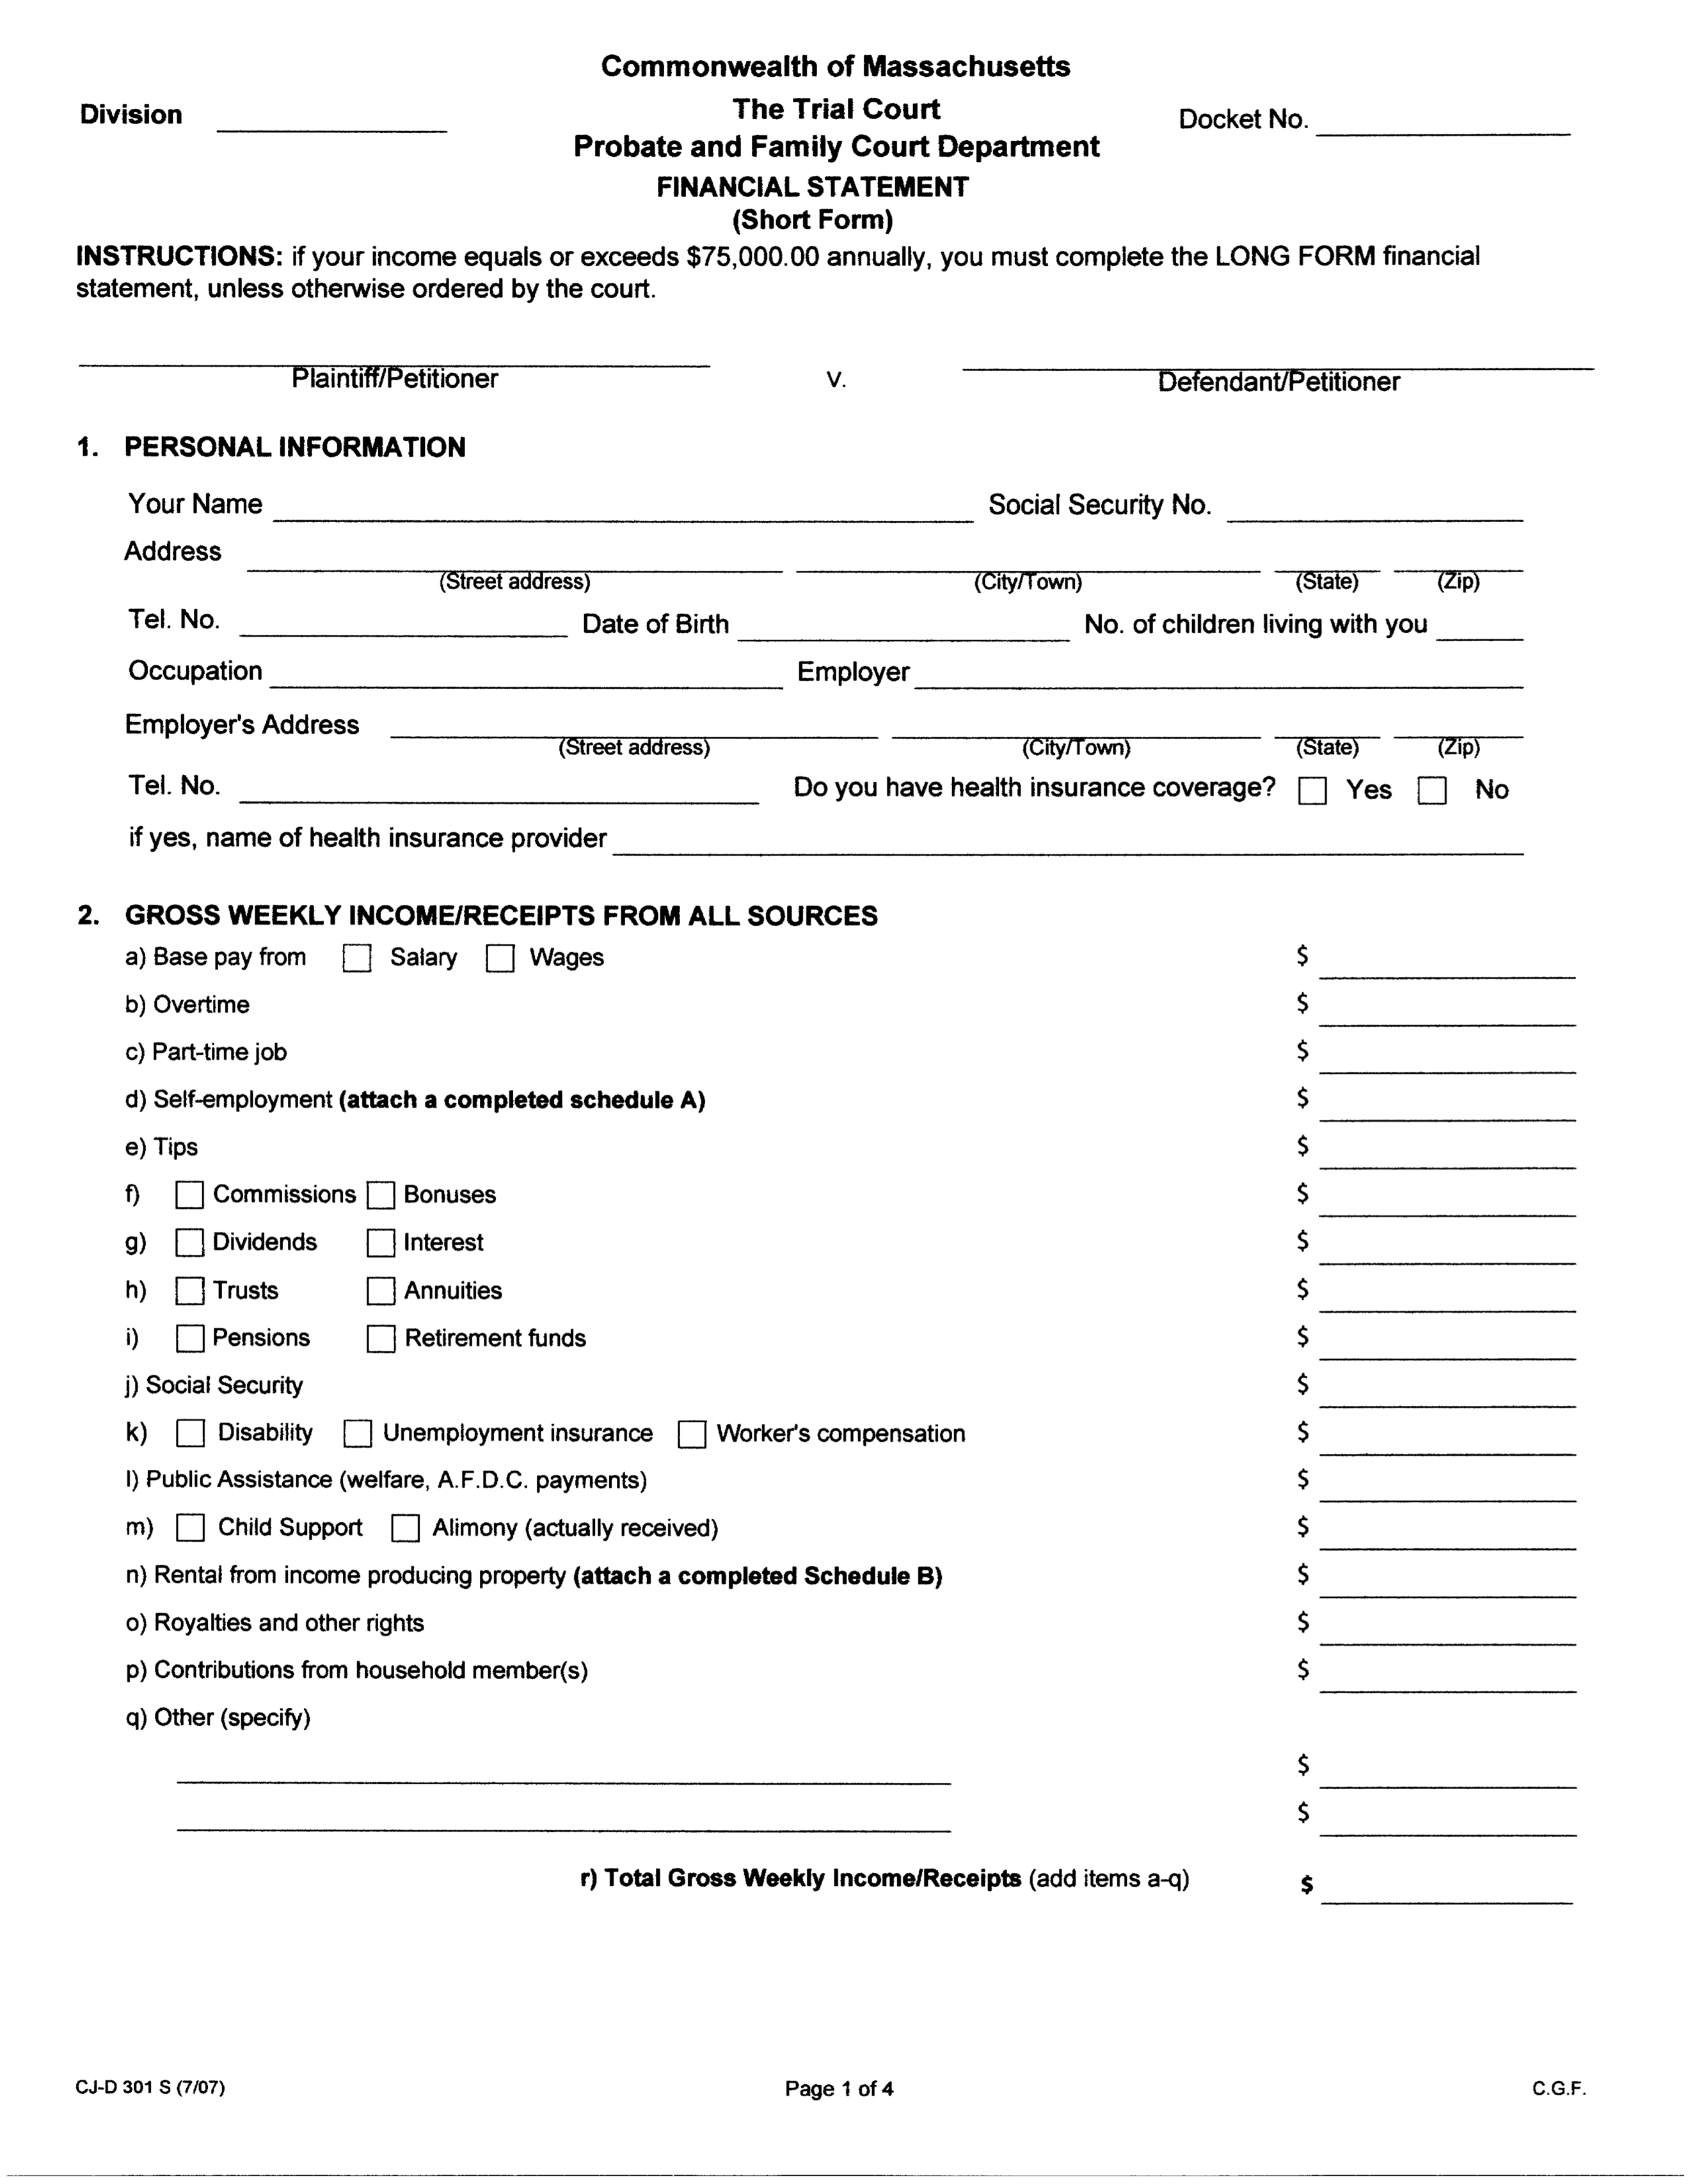

|  |
| --- |
| «What_is_your_full_name» |

|  |  |  |  |
| --- | --- | --- | --- |
| «What_is_your_street_address_you_live_in» | «Which_city_do_you_live_in» | MA | «What_is_your_zip_code» |

|  |
| --- |
| «What_is_your_telephone_number» |

|  |
| --- |
| «What_is_your_date_of_birth» |

|  |  |  |
| --- | --- | --- |
| «What_is_your_occupation_If_you_do_not_» |  | «If_you_have_a_job_what_is_your_employe» |

|  |
| --- |
| «What_is_your_work_address» |

|  |
| --- |
| «What_is_your_telephone_number» |

|  |
| --- |
| «If_yes_what_is_the_name_of_the_provide» |

|  |
| --- |
| «How_much_do_you_get_paid_from_your_job_b» |

|  |
| --- |
| «How_much_is_overtime» |

|  |
| --- |
| «If_you_have_a_parttime_job_how_much_d» |

|  |
| --- |
| «If_you_are_self_employed_how_much_do_y» |

|  |
| --- |
| «How_much_do_you_make_from_tips» |

|  |
| --- |
|  |

|  |
| --- |
|  |

|  |
| --- |
|  |

|  |
| --- |
|  |

|  |
| --- |
| «If_you_have_social_security_how_much_d» |

|  |
| --- |
| «If_you_have_disability_andor_unemploym» |

|  |
| --- |
| «If_you_are_on_public_assistance_how_mu» |

|  |
| --- |
| «If_you_receive_child_support_andor_ali» |

|  |
| --- |
| «If_you_receive_rent_from_a_property_you» |

|  |
| --- |
|  |

|  |
| --- |
| «If_your_family_has_contributed_money_to» |

|  |
| --- |
| «How_much_do_you_receive_from_this_other_» |

|  |
| --- |
| «Do_you_have_other_source_of_income_that» |

|  |
| --- |
| «R_Total_Gross_weekly_income» |

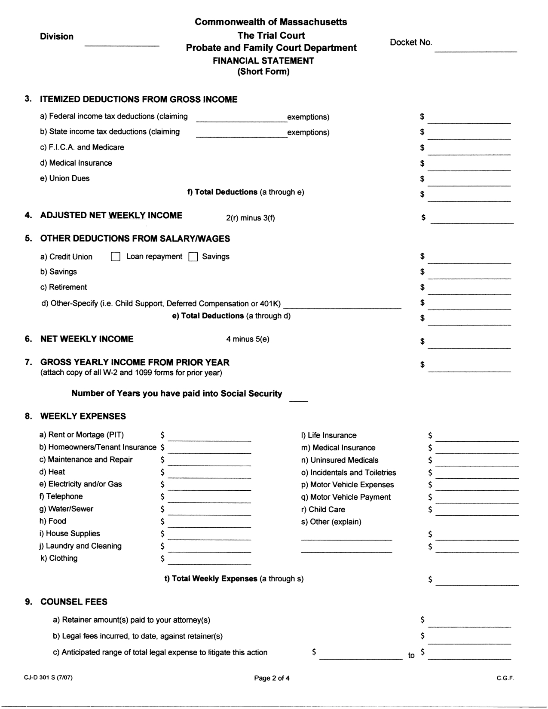

|  |
| --- |
|  |

|  |
| --- |
|  |

|  |
| --- |
|  |

|  |
| --- |
|  |

|  |
| --- |
|  |

|  |
| --- |
|  |

|  |
| --- |
|  |

|  |
| --- |
|  |

|  |
| --- |
|  |

|  |
| --- |
|  |

|  |
| --- |
|  |

|  |
| --- |
|  |

|  |
| --- |
|  |

|  |
| --- |
| «If_you_have_filed_for_taxes_last_year_» |

|  |
| --- |
| «What_is_your_rent_or_mortgage» |
| «How_much_is_your_homeownertenant_insura» |
| «How_much_do_you_pay_for_maintenance_and_» |
| «How_much_do_you_pay_for_heat» |
| «How_much_do_you_pay_for_electricity_and» |
| «How_much_do_you_pay_for_telephone» |
| «How_much_do_you_pay_for_watersewer» |
| «How_much_do_you_pay_for_food» |
| «How_much_do_you_pay_for_house_supplies» |
| «How_much_do_you_pay_for_laundry_and_cle» |
| «How_much_do_you_pay_for_clothing_» |

|  |
| --- |
| «How_much_do_you_pay_for_life_insurance_» |
| «How_much_do_you_pay_for_medical_insuranc» |
| «How_much_do_you_pay_for_uninsured_medica» |
| «How_much_do_you_pay_for_incidentals_and» |
| «How_much_do_you_pay_for_motor_vehicle_ex» |
| «How_much_do_you_pay_for_motor_vehicle_pa» |
| «How_much_do_you_pay_for_child_care_» |
|  |
|  |
|  |

|  |
| --- |
| «t_Total_Weekly_Expenses» |

|  |
| --- |
|  |
|  |
|  |

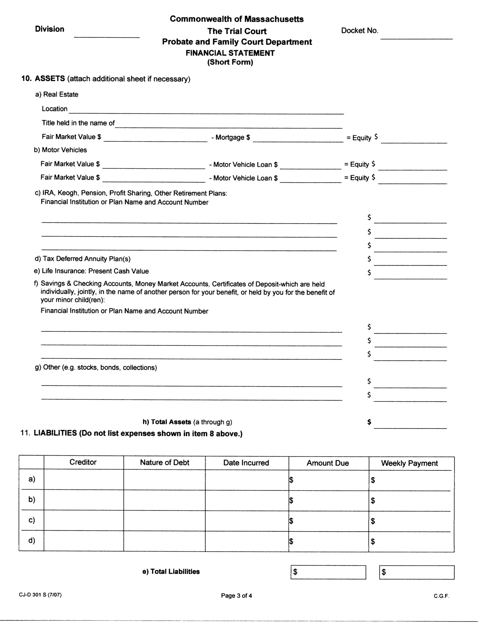

|  |  |  |  |  |
| --- | --- | --- | --- | --- |
| «If_yes_what_isare_the_creditors_name» |  | «When_did_you_borrow_money_from_the_credi» | «How_much_do_you_owe_the_creditor» | «How_much_do_you_pay_back_per_week_if_» |

|  |  |  |  |  |
| --- | --- | --- | --- | --- |
| «Which_bank_do_you_owe_credit_card_paymen» |  |  | «How_much_do_you_owe_the_bank» | «How_much_do_you_pay_back_per_week_if_1» |

|  |  |  |  |  |
| --- | --- | --- | --- | --- |
|  |  |  |  |  |

|  |  |  |  |  |
| --- | --- | --- | --- | --- |
|  |  |  |  |  |

|  |  |
| --- | --- |
| «e_Total_Liabilities» |  |

